**Magical Mine.**

The magical mine is a mine that existed far before your glorious city did. Your workers immediately take possession of it when your city comes into being, and daily you can extract valuable items from it.

As your city becomes more powerful, you can bury deeper and get more numerous and rarer items. As your research increases, you can explore more caverns in the mine at once.

***Magical Mine Screen:***

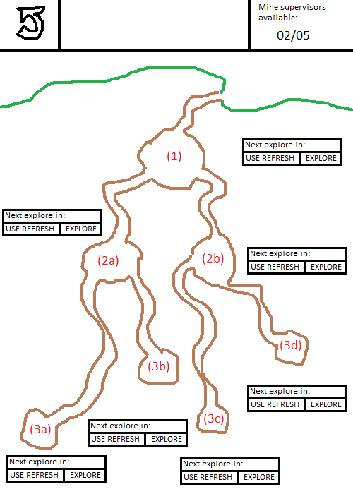

**User Interface (entire screen):**  
**Top left**. Return to base button.  
**Top right**. Information panel showing how many mine supervisors there are available (i.e. additional caverns that can be explored at the same time).  
**1, 2a, 2b, 3a, 3b, 3c, 3d.** The caverns. 3 things are displayed here; the time left before a treasure chest is available, the current and maximum daily explorations, and the current additional explorations allowed.  
**Exploration interface**. One exists for each cavern. From here, you can see how long until an additional daily explore is added to your current allowed. You can also use a refresh in your inventory (or buy directly from store if out), and you can press the EXPLORE/OPEN button, which will set a new time for the next item, or open an item that has been explored.

**User interface (from main base map):**Clicking on the magical mine opens a mini menu rather than sending you directly to the magical mine screen. The options are as follows.  
**Magical Mine**. Takes you to the magical mine screen.  
**Open all items**. Automatically opens and shows you all items that were waiting to be opened.  
**Auto Explore**. Will automatically use any available supervisors on the rarest available caverns first.  
**Supervisor display**. From the main base map, without selecting the magical mine icon, you can automatically view any available supervisors out of the total amount you have. A chest icon also appears next to it when items are ready to be opened.

**Graphics In use:**  
GS_001: Magical Mine screen  
GIMB_041: Magical Mine Icon (to navigate to this screen from main base)  
GIA_001: Explore Icon. Appears over a cavern that is ready to be explored.  
GIA_002: Chest Icon: Appears over a cavern that has been explored and completed its countdown.  
GIA_003: Lock Icon. Appears over caverns that are not available yet.

**Unlocking levels is tied to base level.**  
Level 1: Original mine area.  
Level 2: Unlocked when your base becomes level 10.  
Level 3: Unlocked when your base becomes level 20.  
Level 4 (future): Unlocked when your base becomes level 30.

**Items obtainable from caverns:**

For all the items and the probabilities with which they drop, refer to the spreadsheet “stats for rts”.